Wh-Clause as a Verb Complement

✅ What Is a Wh-Clause as a Verb Complement?
# Source: AI Source: Provided by: [Data Path: Persons Table -> ID Column: 1, Name_En Column: Motasem Essam] -> From: [ChatGPT] on [8/4/2025]
A wh-clause is a dependent noun clause introduced by a wh-word (who, what, when, where, why, how, which, etc.). It functions as a verb complement by completing the meaning of certain verbs that require detailed information.

🔸 Structure:
# Source: AI Source: Provided by: [Data Path: Persons Table -> ID Column: 1, Name_En Column: Motasem Essam] -> From: [ChatGPT] on [8/4/2025]
- Verb + wh-clause
- Common after verbs like: explain, describe, show, ask, tell, know, wonder, etc.

🔸 Examples:
# Source: AI Source: Provided by: [Data Path: Persons Table -> ID Column: 1, Name_En Column: Motasem Essam] -> From: [ChatGPT] on [8/4/2025]
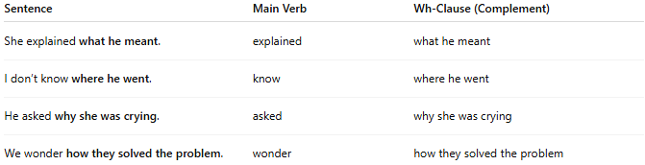
Sentence | Main Verb | Wh-Clause (Complement)
She explained what he meant. | explained | what he meant
I don’t know where he went. | know | where he went
He asked why she was crying. | asked | why she was crying
We wonder how they solved the problem. | wonder | how they solved the problem

🔸 Why It's a Verb Complement:
# Source: AI Source: Provided by: [Data Path: Persons Table -> ID Column: 1, Name_En Column: Motasem Essam] -> From: [ChatGPT] on [8/4/2025]
The wh-clause completes the verb’s meaning by providing the specific content of what was explained, asked, known, etc.
🟢 Example:
- ✅ "She explained what happened." (complete)
- ❌ "She explained." (incomplete – explained what?)

